Dr Mark Porter: Painkillers such as ibuprofen can be lethal. These are the alternatives

Anti-inflammatories are effective and widely available but could cause bleeding

**Dr Mark Porter**

October 4 2016, 12:01am, The Times

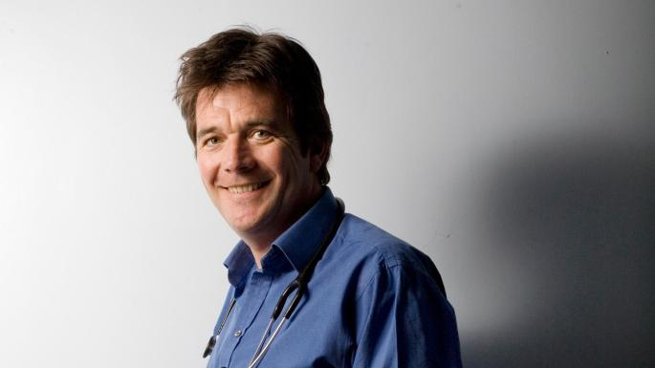

Dr Mark Porter: “One of the worst bleeds I encountered was in a patient who had been taking NSAIDs for only 48 hours”

Painkillers are back in the headlines following a publication of a new study linking non-steroidal anti-inflammatories (NSAIDs) such as ibuprofen, naproxen and diclofenac to heart failure. The researchers found that older people taking them are about 20 per cent more likely to develop heart failure. And it is not the only time this family of drugs has been linked to serious complications.

The average age of the people in the study was close to 80 — an older group already prone to heart problems — so the findings have little relevance for the rest of us, but they do provide a timely reminder that NSAIDs are a double-edged sword. On the one hand they offer effective relief for everything from headaches and period cramps to back pain and arthritic joints. However, on the other they have been linked to side-effects ranging from diarrhoea to kidney failure.

The main danger when taking an NSAID is bleeding from the stomach — a complication that kills at least 2,000 people across the UK every year and hospitalises many thousands more. And it is a side-effect that can occasionally strike quickly and without warning. One of the worst bleeds I encountered was in a patient who had been taking NSAIDs for only 48 hours to relieve an attack of gout. He survived but the experience taught us both a lesson we shall never forget.

It is not just bleeds that should ring alarm bells when considering an NSAID. They can worsen cough and wheeze in some people with asthma, put the kidneys under strain (a real issue if yours are already struggling), cause fluid retention (puffy ankles and breathing problems) and raise blood pressure. More recently they have been linked to heart attack and stroke — the increase in risk is small but enough to prompt a move back to an older NSAID, naproxen, which appears safer in this respect.

The problem is these drugs work well, are easy to take (typically just twice a day) and don’t cause drowsiness, which explains why they are popular with prescribers, patients and people self-medicating over the counter. It is important to get a sense of perspective. Tens of millions of prescriptions for naproxen and other NSAIDs are issued every year in the UK and most people on them have no issues. That said, it pays to take a few basic steps to minimise the risk.

If you are self-medicating for headaches or sprains and strains, try paracetamol first. The latest evidence suggests that it is not much better than a placebo for problems such as back pain or an aching knee, but that doesn’t mean it won’t help — the placebo effect is very powerful when it comes to pain and paracetamol can still provide relief for some.

If paracetamol doesn’t do the trick, by all means try over-the-counter ibuprofen but stick to the lowest dose for the shortest amount of time, and talk to your pharmacist if any of the cautions below apply to you. If your doctor is prescribing an NSAID, it is likely you will be offered naproxen with an anti-acid medicine (typically omeprazole) to protect the lining of your stomach. If not, ask why.

If your doctor is prescribing an NSAID, it is likely you will be offered omeprazole to protect the lining of your stomachILLUSTRATION BY JOE MCLAREN

Topical NSAID creams and gels are safer options that help some people, but the placebo effect is significant here too. Still, worth a try.

I am particularly wary of using NSAIDs in people on low-dose aspirin (itself an NSAID and a drug that induces bleeding), and in those taking steroids and Prozac-like antidepressants (both of which inflame the stomach). Aspirin is a particular red flag because if a patient is taking the drug it suggests they are already at high risk of heart attack or stroke, and an NSAID is only going to make that worse.

If you are worried, please don’t stop your medication or rush to see your doctor. These hazards are not new and the chances are your GP has already considered all of the above and taken steps to minimise your risk, but do raise any concerns at your next consultation.  
**The NSAID heart failure study is published in the latest edition of the** ***British Medical Journal***

**Who is most at risk from anti-inflammatory drugs?**

■ Anyone with a history of stomach bleeds or ulcers

■ The over-65s

■ People taking high doses for long periods

■ Anyone with high blood pressure, heart disease, a previous stroke or heart failure

■ People with poor kidney function

■ Some people with asthma

■ Pregnant women, or those trying to conceive (NSAIDs may impair fertility)

■ Anyone taking steroids, antidepressants or “blood thinners” (eg, aspirin or anticoagulants)

**Q&A**

**Q Thank you for last week’s guide to looking after your heart, but I was a bit disappointed that you didn’t mention how heart attacks can present differently in women — many of whom don’t get the classic symptoms you listed.**

**A** Good point. I have covered this anomaly in the past. Although most women having a heart attack do complain of the classic crushing chest pain, some develop more subtle symptoms ranging from a vague sense of pressure in the chest that spreads to the shoulders, neck and upper back to feelings of anxiety, a stomach ache, shortness of breath and general fatigue. All of which are easily confused — by both patient and doctor — with less sinister conditions such as stress and indigestion.

Plus women tend to seek help later than men because they often think it won’t happen to them — poor awareness that continues despite, as I pointed out, coronary heart disease now killing three times as many women as breast cancer.

And delays in diagnosis cost lives. While 1 in 7 middle-aged men dies within 30 days of admission, the figure for women of the same age is closer to 1 in 5 and late/missed diagnosis is responsible for much of this difference. **If you have a health problem, email**[drmarkporter@thetimes.co.uk](mailto:drmarkporter@thetimes.co.uk)